cPlease critique and improve-*

1. 1. 1. 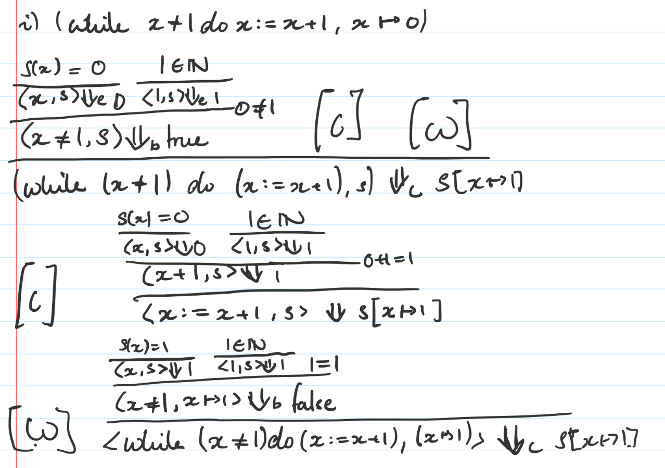
      2. ( is total if forall there E exists a v) $⇓_{c}$ 
           
          is not total because we can use a variable that is not defined, i.e. $s(x)=n$ is never true. The other way in which $⇓_{c}$ is not total is for an expression such as:  
         while true do x := x + 1, as this would never finish.

(I think it’s also important to mention the composition of commands might also lead to a program not terminating, so there’s 3 ways in which $⇓_{c}$ is not total)

Alternative answer:

All the command rules only modify the state without actually reducing to a value.



$P(E)=∃v.E⇓_{e'}v$

Base Cases

$$P(n)=∃v.n⇓_{e'}v$$ Holds by setting $v=n$, then holds by $\frac{n∈N}{<n,s>⇓_{e'}n}$. $$P(x)=∃v.x⇓_{e'}v$$ 
  
Two cases to consider, $x∈dom(s)$,  
Apply $\frac{s(x)=n}{<x,s>⇓_{e'}n}$. So set $v=n$, holds. $x∉dom(s)$ 
,  
Apply $\frac{x∉dom(s)}{<x,s>⇓_{e'}error}$. So set $v=error$, holds.  
  
Inductive step $$P(E_{1}+E_{2})=∃v_{3}.(E_{1}+E_{2})⇓_{e'}v_{3} \\ Inductive hypotheses:$$ $Assume ∃v_{1}.E_{1}⇓_{e'}v_{1}$
 and $∃v_{2}.E_{2}⇓_{e'}v_{2}$ hold.  
  
Only one rule applies. By this rule (can’t be bothered to write it out), since we have $v_{1}, v_{2}$, and $E_{1}+E_{2}⇓_{e'}v_{3}$ where $v_{3}=v_{1}+v_{2}$ exists (either as a natural number or error), so holds.

* + 1. Assuming we already have $⇓_{e'}$ we propagate *error* forward.  
         
       Imagine all the existing rules and add:  
         
          
         
       + while rules which also have error propagating ‘left to right’.
    2. $⇓_{c'}$ is still not total because we can create situations where there is an infinite loop.  
       e.g. <while true do x:=x+1, x->0>  
         
       We could adjust c’ to catch this example, but can always reformulate the condition or loop body to get around this. Hence c’ is not total.

1. 1. 1. ~~Since the function is f: NxN -> N I’m guessing that $R_{0}$ and $R_{1}$ are the argument registers and that $R_{0}$ is the result register.  
         With this assumption, the function computed is $R_{0}=R_{0}+R_{1}$, i.e. addition.~~  
         By definition on the slides, this might be a trick question. $R_{0}$ 
          is 0 by default, and contains the value that f computes once the machine halts. Then $R_{1}$, $R_{2}$ correspond to the two arguments. The machine does not make use of $R_{2}$, but that doesn’t matter.  
           
         f returns the first of its arguments, i.e. copies $R_{1}$ into $R_{0}$. $$f:N×N→N$$ $f(x, y) = x$
      2. L0 = R1- → L1, L2 = ⟪3, ⟨1,2⟩⟫ = 152  
         L1 = R0+ → L0 = ⟪0, 0⟫ = 1  
         L2 = HALT = 0  
           
         Prog = list(152, 1, 0) = ⟪152, ⟪1, ⟪0, **0**⟫⟫⟫ = ⟪152, ⟪1, 1⟫⟫ = ⟪152, 6⟫ = $2^{152}×13$
      3. R_0 is the result, 0 by default  
         R_1 is the program (same as above)  
         R_2 is the list of arguments ⟪2,⟪1, 0⟫⟫=⟪2, 2⟫= $2^{2}×5$.   
           
         All other registers are set to 0.
   2. 1. ~~I found it more intuitive to convert the rules into actual lambda calculus  
           
         To show (SKK)x = Ix  
           
         (SKK)x = $[(λxyz.xz(yz)) K K] x$ by RED-S $$→_{β}[(λyz.Kz(yz)) K] x \\ →_{β}(λz.Kz(Kz)) x \\ Kz = (λxy.x)z→_{β}λy.z \\ So [λz.(λxy.x)z(λy.z)]x→_{β}[λz.(λy.z)(λy.z)]x→_{β}[λz.z]x$$ $[λz.z]x$
         = Ix from RED-I~~

*Alternatively, using their rules:*

b) i. SKK) x -> Kx (Kx)

-> x

ii. (SII) x -> Ix (Ix)

-> x (Ix)

-> x x

iii. S’ S’ = (S (Kx) (SII)) S’

-> (Kx) S’ ((SII) S’)

-> x ((SII) S’)

-> x (IS’ (IS’))

-> x (S’ (IS’))

-> x (S’ S’)

iii. *Alternative: Last 3 steps can be replaced with single step using rule from part ii*

S’ S’ = (S (Kx) (SII)) S’

-> (Kx) S’ ((SII) S’)

-> x ((SII) S’)

**-> x (S’ S’)**

Let P(n) ≡ (SII) S’ = xn (S’ S’). We will show that for all n ∈ N+.P(n) holds by induction over n.

*Base case:*

We must show that P(1) holds. We have that:

(SII) S’ -> IS’ (IS’)

-> S’ (IS’)

-> S’ S’

-> x (S’ S’) by previous part

= x1 (S’ S’) by definition provided

*Inductive case:*

We must show that P(k+1) holds, assuming P(k) ≡ (SII) S’ = xk (S’ S’) (not sure how we can really use this) as our inductive hypothesis. We have that:

(SII) S’-> IS’ (IS’)

-> S’ (IS’)

-> S’ S’

-> x (S’ S’)

-> x (x (S’ S’))

-*> x ( … x (x (S’ S’)))

(k times)

-> x ( … x (x2 (S’ S’)))

(k - 1 times)

-> x ( … x (x3 (S’ S’)))

(k - 2 times)

-*> x (xk (S’ S’))

= xk+1 (S’ S’) by definition provided

***

Proving P(k+1) using P(k):

Could apply the provided definition of equality - show that xk+1 (S’ S’) →* z and (SII)S’ →* z for some common z.

xk+1 (S’ S’) →* x(xk (S’ S’)) by def  
 →* x((SII) S’) by inductive hypothesis P(k)  
 →* x(S’S’) by Q2(b)(ii)  
 →* S’S’ by first part of this question (show S’S’ = x(S’S’))

(SII)S’ →* S’S’ by Q2(b)(ii)

By definition of the equality relation between combinator terms provided on the question paper, xk+1 (S’ S’) = (SII) S’, as required.

***